=

Title: Design and Implementation of Data Loss
Prevention (DLP) System for Network Security

1. Introduction
Data leakage is a major security concern for organizations because sensitive information such as passwords, confidential documents, personal data, and financial information can be transmitted across networks without authorization. Data Loss Prevention (DLP) systems help detect and monitor such activities.
This project implements a Network-Based Data Loss Prevention System using Snort 3. The system monitors network traffic, inspects packet contents, detects sensitive information patterns, and generates alerts when confidential data is found. The implementation was carried out using Ubuntu Linux, Kali Linux, Snort 3, and network testing tools.

2. Objectives
- To install and configure Snort 3 on Ubuntu Linux.
- To monitor network traffic in real time.
- To create custom DLP detection rules.
- To detect sensitive information within network packets.
- To generate alerts for suspicious activities.
- To analyze network traffic using security monitoring tools.

3. Problem Statement
Organizations exchange sensitive information through networks every day. Without proper monitoring, confidential information may be leaked intentionally or accidentally. There is a need for a low-cost security solution that can monitor network traffic and detect sensitive information before data leakage causes damage.

4. Proposed Solution
The proposed solution uses Snort 3 as a network-based DLP and Intrusion Detection System. Custom detection rules are created to inspect packet contents and identify sensitive information patterns.
The system:
- Monitors network traffic.
- Detects sensitive data within packet payloads.
- Generates security alerts.
- Logs suspicious activities.
- Assists administrators in identifying possible data leakage attempts.

5. System Architecture

Components Kali Linux
Used to generate test traffic and perform security testing.
Ubuntu Linux
Hosts the Snort 3 monitoring system.
Snort 3
Performs packet inspection and rule-based detection.
Network Interface
Captures incoming and outgoing network traffic.
Alert and Logging System
Displays and records detected security events.

6. Tools and Technologies Tool Purpose
Snort 3 Intrusion Detection and DLP Monitoring
Ubuntu Linux Monitoring Platform
Kali Linux Security Testing
Nmap Network Scanning
Netcat (nc) Traffic Simulation
Wireshark Packet Analysis
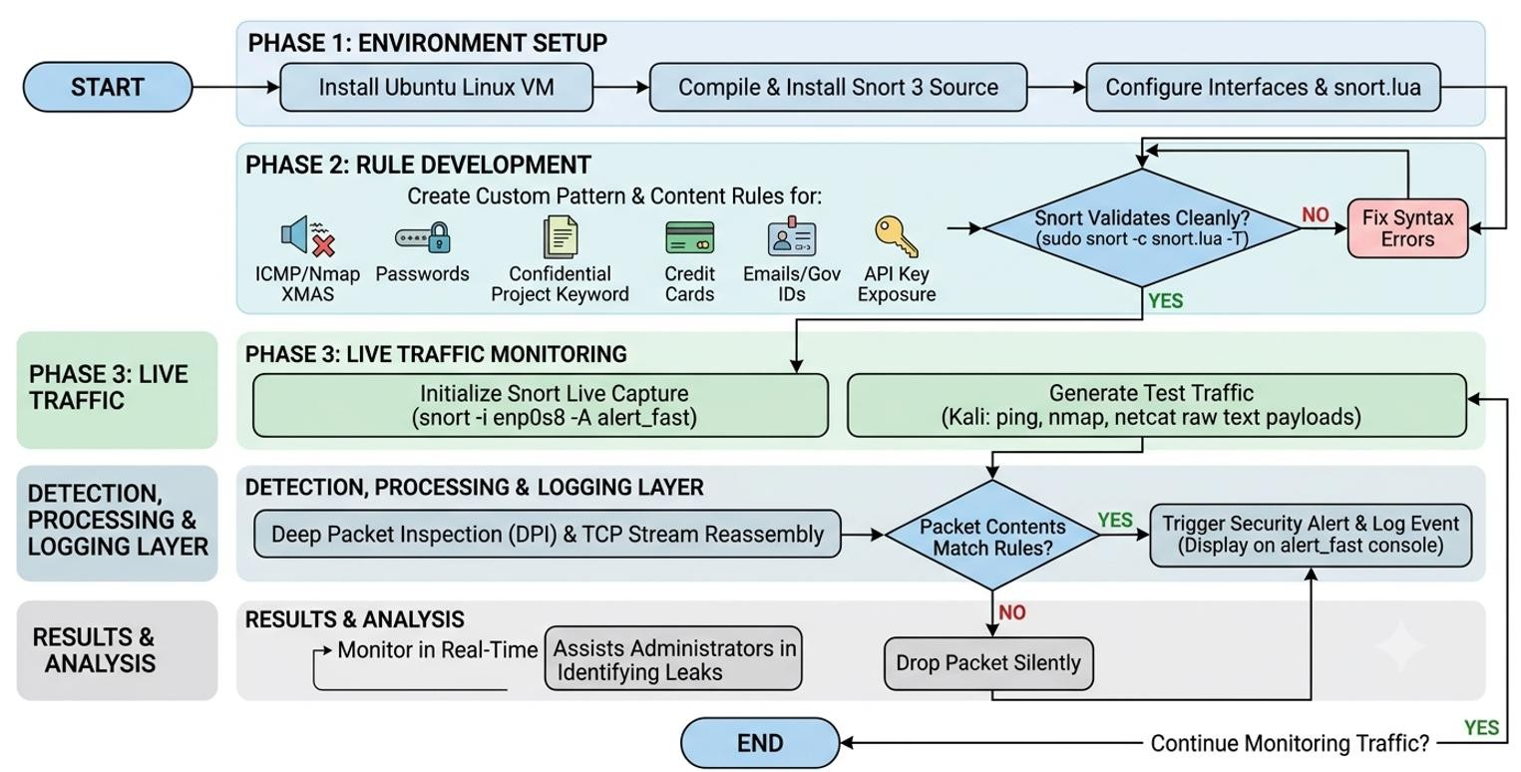

7. Methodology

Phase 1: Installation
- Installed Ubuntu Linux virtual machine. • Installed required Snort 3 dependencies.
- Compiled and installed Snort 3 from source code.

Phase 2: Configuration • Configured Snort 3 environment.
- Created custom rule files.
- Configured monitoring interfaces.
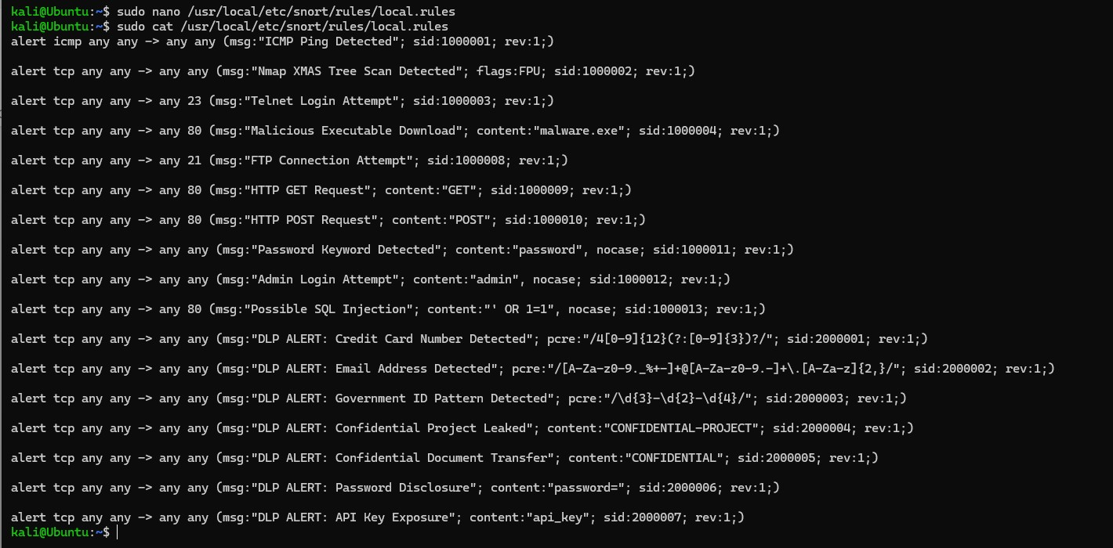
Phase 3: Rule Development Custom rules were developed for:
- ICMP Ping Detection
- Nmap XMAS Scan Detection
- Telnet Connection Detection
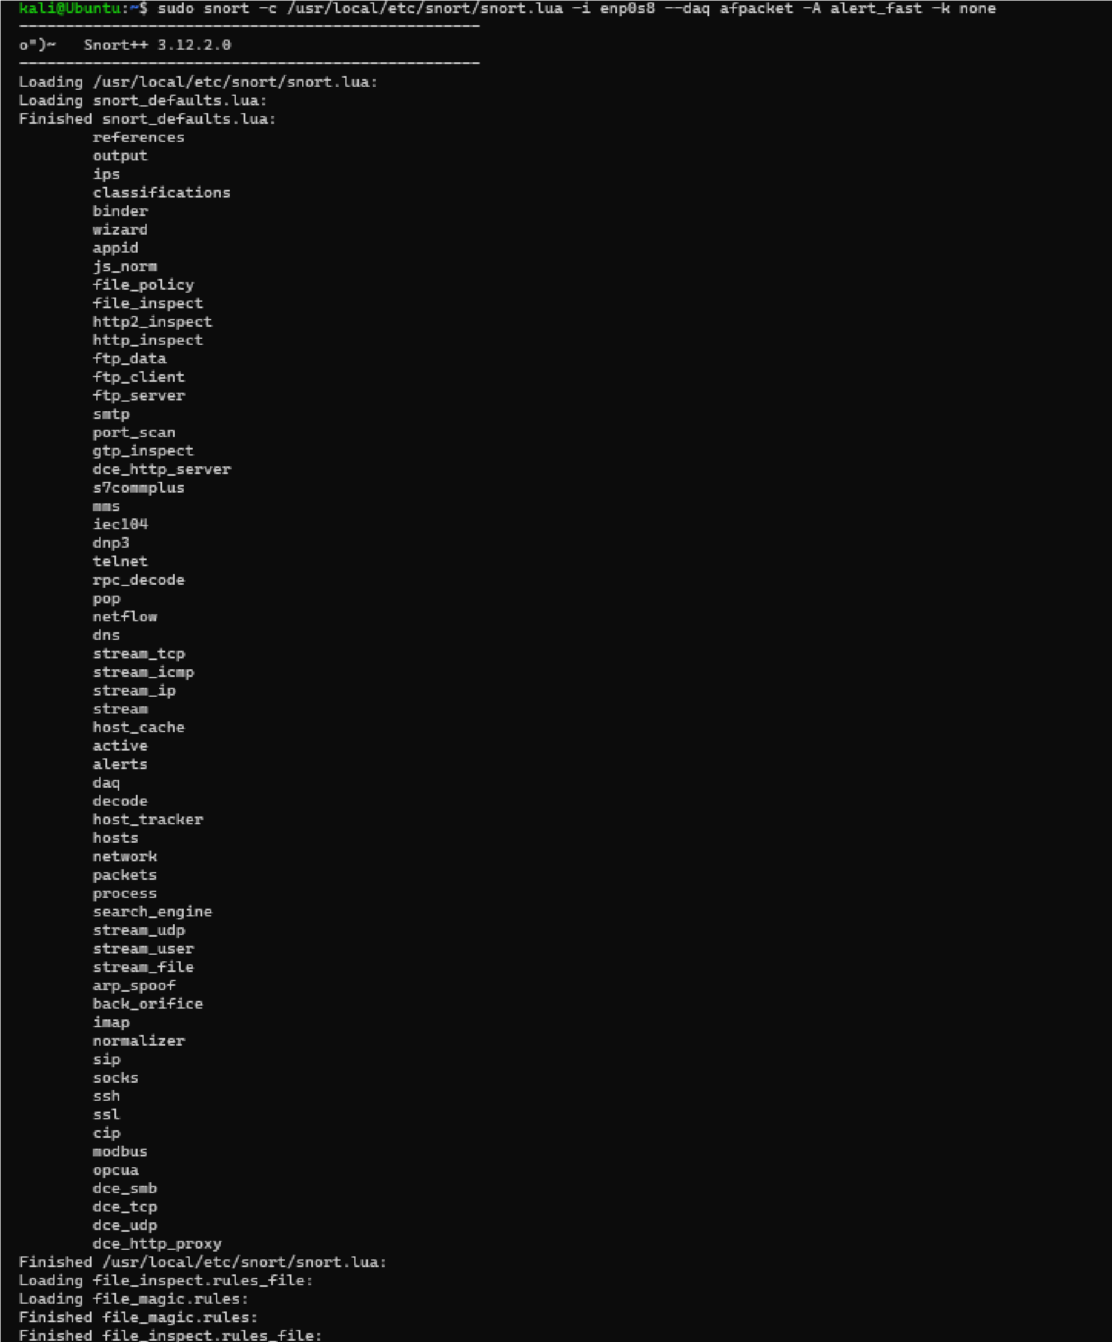
- Malicious Executable Detection
- Password Disclosure Detection
- Confidential Project Keyword Detection
- Credit Card Pattern Detection
- Email Address Detection
- Government ID Pattern Detection
- API Key Exposure Detection

Phase 4: Testing
Traffic was generated using:
- Ping
- Nmap
- Netcat
The generated traffic was analyzed by Snort and alerts were successfully produced.
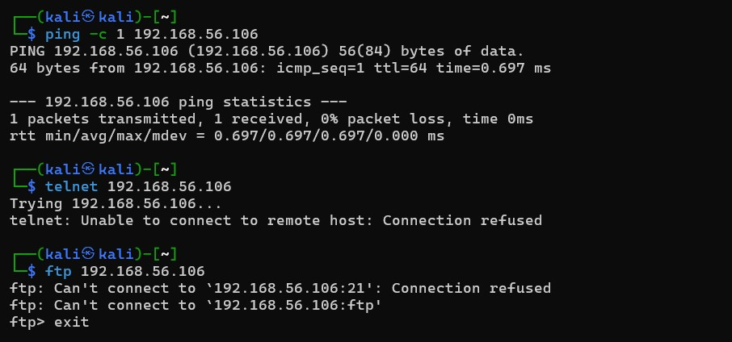
When testing everything on just one machine, Snort stayed silent because the system processed the data internally in memory, completely bypassing the network card. To fix this, I used a separate Kali Linux machine. This forced the data to travel as real packets over the virtual network interface to reach the Ubuntu machine where Snort was watching.
To capture these packets successfully, I configured Snort to use the AFPacket module. This allowed Snort to monitor the network card directly and inspect traffic moving in both directions—both incoming connections and outgoing data. When I sent the sensitive phrase across the network, the packet crossed the monitored network interface. Snort immediately inspected the packet, matched the confidential keyword signature, and successfully fired a realtime security alert.

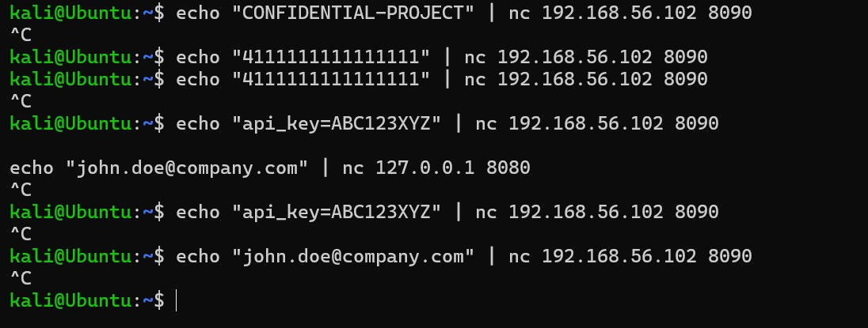
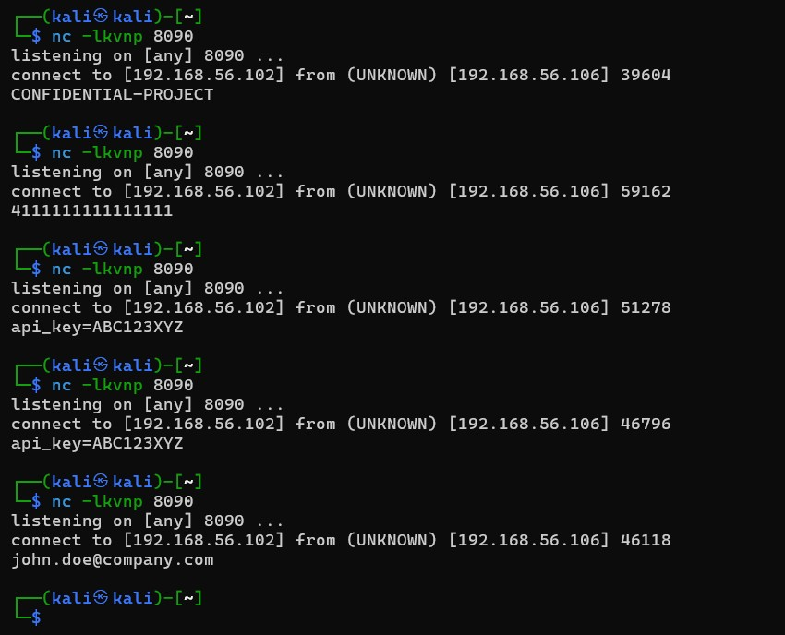

8. Implemented Snort Rules
ICMP Ping Detection Detects ICMP ping packets.
Nmap XMAS Scan Detection
Detects reconnaissance scans using FIN, PSH, and URG flags.
Telnet Login Detection
Detects connections targeting TCP port 23.
Malicious Executable Detection
Detects references to malware executable downloads.
Password Disclosure Detection
Detects passwords transmitted in plain text.
Confidential Project Detection
Detects confidential project identifiers.
Credit Card Detection
Detects Visa credit card number patterns.
Email Address Detection
Detects email addresses within network traffic.
Government ID Detection
Detects sensitive identification number patterns.

API Key Detection
Detects exposed API credentials.

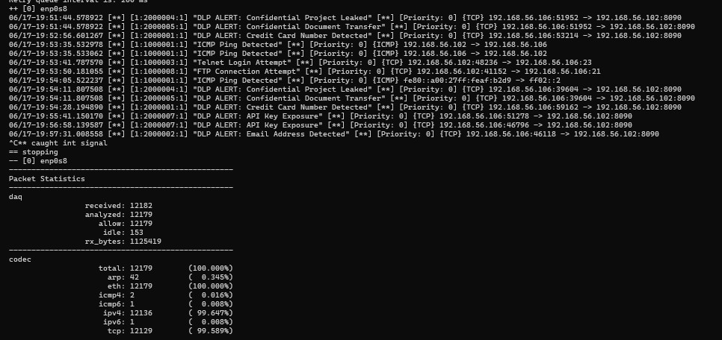

9. Key Features
- Real-time network monitoring
- Deep packet inspection
- Custom DLP rule creation
- Sensitive data detection
- Alert generation
- Network traffic analysis
- Security event logging

10. Results
The implemented system successfully:
- Detected ICMP ping traffic.
- Detected Nmap XMAS scans.
- Detected Telnet connection attempts.
- Detected confidential keywords.
- Detected password disclosures.
- Detected credit card patterns.
- Detected email address patterns.
- Generated alerts in real time.

11. Limitations
- Detection depends on predefined Snort rules.
- Encrypted traffic cannot be fully inspected.
- Designed for laboratory and educational environments.
- Does not include automatic blocking mechanisms.

12. Conclusion
This project successfully implemented a Network-Based Data Loss Prevention System using Snort 3. Custom detection rules were developed to identify sensitive information and suspicious activities within network traffic. The system demonstrated the ability to monitor packets, detect potential data leakage, and generate real-time security alerts, providing a practical and cost-effective information security solution.

